All electronic devices are subject to noise – pixels that, for one reason or another, take on an incorrect color or intensity. This is partly due to the changes in temperature that arises from the heating of electrons in the device. In addition to noise generated by temperature changes, noise is also generated when light hits the image sensor in your digital camera. Noise, which often appears as speckles on an image, is one way that digital images are degraded. There are two common types of noise: Salt & Pepper and Gaussian. Figure 1 below shows an example of salt and pepper noise, where randomly occurring black and white pixels replace the light intensity of the original pixel. Figure 2 shows an example of Gaussian noise, which involves “normally distributed” noise that is more likely to occur at specific values.

 

Figure 1 (left): Image w/ Salt and Pepper noise  
Figure 2 (right): Image w/ Gaussian noise

Salt and pepper noise also known as grainy noise occurs in the form of pixels with black or white intensities that appear to be scattered on an image (Figure 1). Another type of noise prevalent in digital images is Gaussian noise also known as snowy noise. Gaussian noise produces an effect on the image similar to an old television set with poor reception. It is characterized by two parameters, mean and variance. The intensity of each pixel in the image will differ from its original value by some average value. The variance specifies how much the noise will vary from the average value. The result is a random fluctuation of the intensity of each pixel in the image.

One important question that needs to be considered when developing digital camera or digital photo software is how to remove commonly occurring noise from images. In the activities below we explore two common methods for removing noise.

In order to remove noise from an image we may employ two commonly used algorithms. The first method samples a block of pixels and calculates the mean value. It replaces the pixel in the center of the block with this mean value. The other algorithm works similarly, but instead calculates the median value instead of the mean.

#### Activity 1: Denoising an Image by Hand

### **I. “Smoothing” with the Mean.** The following procedure can be used to “smooth” an image and reduce noise.

1. Start at the upper-left cell in the matrix (43).
2. Calculate the mean of all the cells including your selected cell (43,102, 122, 55).
3. Replace the value (e.g. 43) in the original cell with the mean calculated above.
4. Move one pixel to the right and continue to calculate means and replace the value in your current cell with the mean of all the cells. For example, there will be nine cells the surrounding and the given “central” cell – the value of that cell would be replaced by the mean of all eight surrounding cells.

***Note:*** when calculating the mean use the original pixel intensity values **not** the previously calculated means.

1. *Now try it out.* Consider the portion of a digital image shown below in Figure 3. Follow the procedure outlined above to “smooth” the image and enter your new means in the blank matrix in Figure 4.

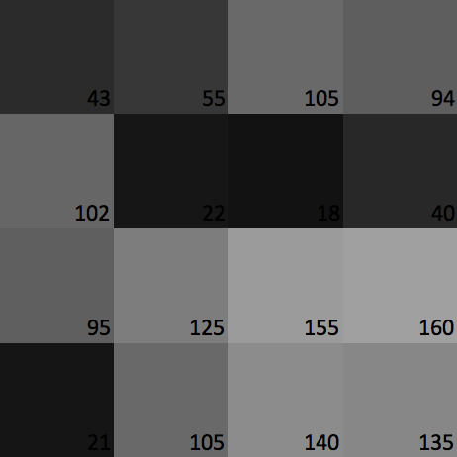

Figure 3: Portion of a Digital Image

|  |  |  |  |
| --- | --- | --- | --- |
| 43 | 55 | 105 | 94 |
| 102 | 22 | 18 | 40 |
| 95 | 125 | 155 | 160 |
| 21 | 105 | 140 | 135 |

Figure 4: Blank Matrix for Mean Smoothing

1. Download the Excel document from <http://dk12.ece.drexel.edu/MT/smoothing.xlsx> and replace the original values with your calculated values. The Excel spreadsheet automatically re-calculates the color of the cell to match your entry. What do you notice? How is the image different?

### **II. “Smoothing” with the Median.** A similar procedure can be used to “smooth” an image and reduce noise using the median instead of the mean.

1. Start at the upper-left cell in the matrix (43).
2. Calculate the median of all the cells surrounding your selected cell (43, 102, 122, 55).
3. Replace the value in the original cell with the median calculated above.
4. Move one pixel to the right and continue to calculate medians and replace the value in your current cell with the mean of all the cells. For example, the median of the nine cells will replace a given “central” cell.

***Note:*** when calculating the medians use the original pixel intensity values **not** the previously calculated means.

1. *Now try it out.* Revisit digital image shown in Figure 3. Follow the procedure outlined above to “smooth” the image and enter your new values (the median of the surrounding cells) in the blank matrix in Figure 5.

|  |  |  |  |
| --- | --- | --- | --- |
| 43 | 55 | 105 | 94 |
| 102 | 22 | 18 | 40 |
| 95 | 125 | 155 | 160 |
| 21 | 105 | 140 | 135 |

Figure 4: Blank Matrix for Median Smoothing

1. Return to the Excel document you downloaded from <http://dk12.ece.drexel.edu/MT/smoothing.xlsx> and replace the original values with your calculated values (the medians). The Excel spreadsheet automatically re-calculates the color of the cell to match your entry. What do you notice? How is the image different? How is the resulting “smoothed” image different from the mean smoothing?

#### Activity 2: Denoising Applets

1. Download a quality image of the cat from Figures 1 & 2 from <http://dk12.ece.drexel.edu/MT/cat.jpg>
2. Open the “Noise” applet at <http://dk12.ece.drexel.edu/image_guis/Noise.html> or following the link on the main Image Processing Labs page.
3. The applet is designed to add either Salt & Pepper or Gaussian noise to an image and then apply the Mean and Median filter from Activity 1 to the corrupted (noisy) image.
   1. Selecting Gaussian or Salt and Pepper determines the kind of noise that will be added to the image
   2. The Mean slider determines the mean of the noise Gaussian distribution. It is best to leave it at 0, since this reflects most real-world noise.
   3. The Std slider slider determines the standard deviation (STD) of the noise Gaussian distribution. One can leave it at its default of 50, but this is usually very strong noise. Once you click the update button, lower the noise level by dragging it closer to 0 (negative standard deviation will again be too strong of noise).
   4. The Noise Intensity slider affects the frequency of (or how often) pixels are corrupted in the Salt-and-Pepper noise.
   5. The Window slider affects the size of the window to take the mean and median of through the image.
4. Experiment with the various types of noise and sliders.
   1. Click on the Salt-and-Pepper noise. Set the Noise intensity slider to 12 and the Window slider at 5 px. Click Update. Which filter better cleaned the noise better? Why?
   2. Now, set the Window slider to 3 px. Click Update. Are the filtered images clearer or blurrier? Why do you think so?
   3. Now, click on the Gaussian noise, slide the Mean slider to 0, slide the Std slider to 41, and the Window slider to 5px. Click Update. Which filter cleaned the noise better? Why?
5. Questions
   1. As you experimented with the window size what trade-offs in image quality did you notice?
   2. As you experimented with the mean and median algorithms what different “performance” did you notice? Was the mean or median better? Can you make a guess as to why?